

FEES: 2025/2026 GAMING YEAR

Dear Member

MSSA registration and affiliation fees are due and payable on the 1 November of each year.

Please note that if your club has an SLA for an event after the year-end (31 October 2025), such club must pay its affiliation fees and pay its registration fees for all its committee members by no later than 20 November 2025. Should such a club fail to do so, such SLA shall be vitiated.

In order for any player to stand for any office, the club to which the person is affiliated must be fully-up-to-date and have paid its affiliation fees, for 2025/2026, submitted the Club Information Form, and must have paid such person’s registration fees as well as those for at least two other persons.
Please note that other members that do not remit payment by 1 February 2024 shall have their affiliation terminated and their members shall not be allowed to participate in Mind Sport South Africa's events or team selection.
Please note, however, that clubs remain liable for all financial liabilities even if their membership is terminated.

Members may only participate in a MSSA meeting if such member is fully-paid-up at the time of such meeting.

The fees for the 2025/2026 gaming year (1 November 2025 to 31 October 2026) are:

Affiliation fees per club |  | R136.778 per annum
Registration fees: | Registered with MSSA | R145.47 per player
Registration fees: | Players who are members of school clubs | R11.94 per player

Please note that Registration Fees may be waived by the Management Board should a player have reached the age of majority and is unemployed, or if the player is a minor and his/her parents are unemployed.

Please note that the voting strength that any member has at the AGM in December is based on the paid-up membership, for whom all details are entered on the Google Drive page. of such member at the date of the AGM.

Fees must be paid directly into the MSSA's bank account held at ABSA. The account number is: 9047667676.
Fees increase by the CPI every year, and for this year the increase was 3.36%.

Yours faithfully
For and on behalf of the Mind Sport South Africa
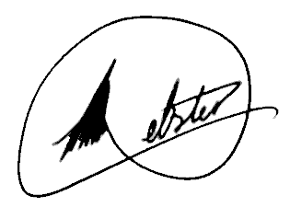
Colin Webster
President

